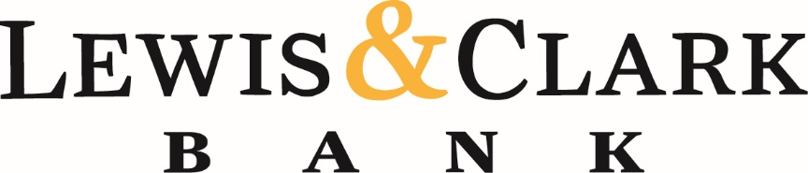
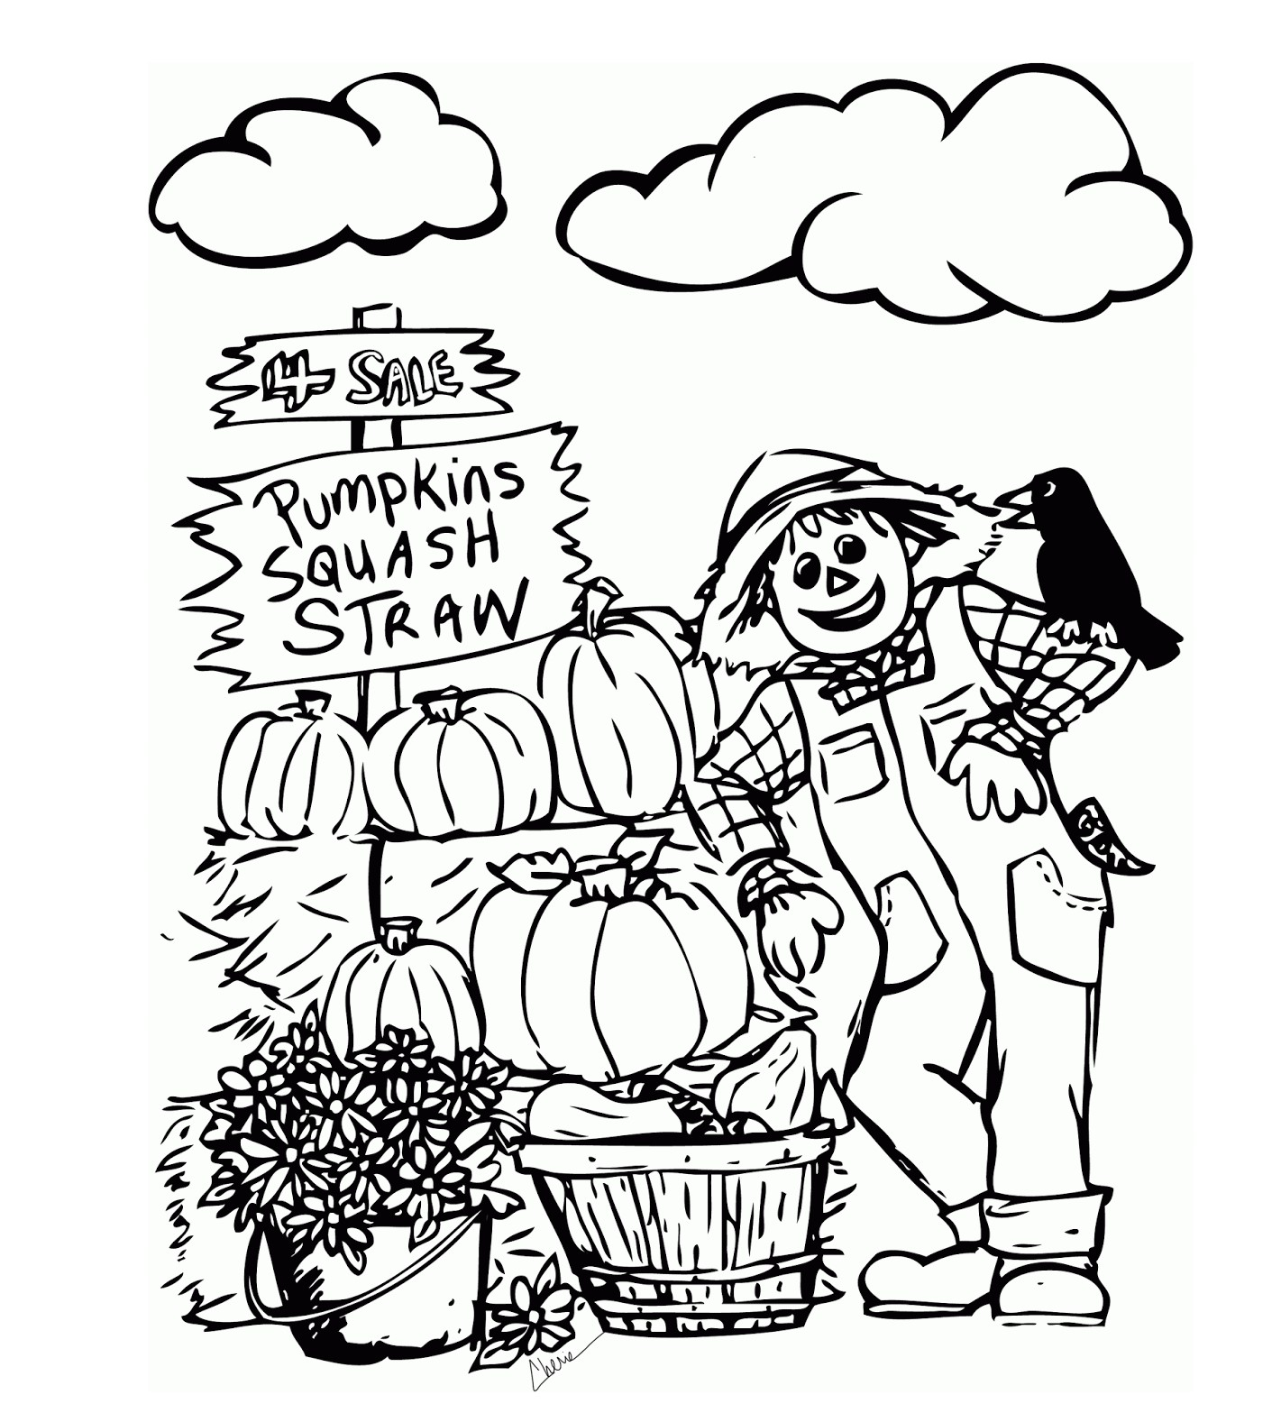

Oregon Community Bank Week Coloring Contest!
October 18th-22nd 2021

Complete and return your masterpiece by
5pm October 22nd, 2021
to your local Branch in Seaside, Astoria or Oregon City
to be entered into the contest.

Age Division will be..
0-4 years old; 5-9 years old; 10-15 years old; 16-18 years old; 18+

Fun Surprise gift baskets will be awarded to our overall 1st place winners in each age division!

Winners will be announced via Facebook and our Webpage on October 29th, 2021
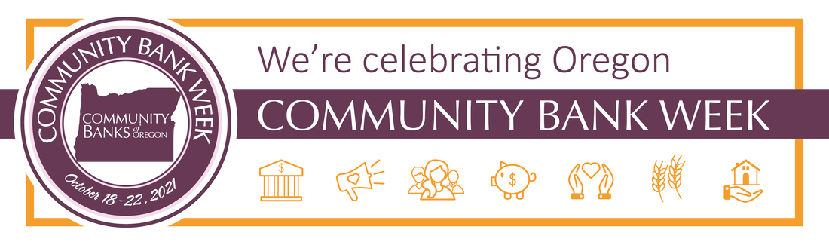

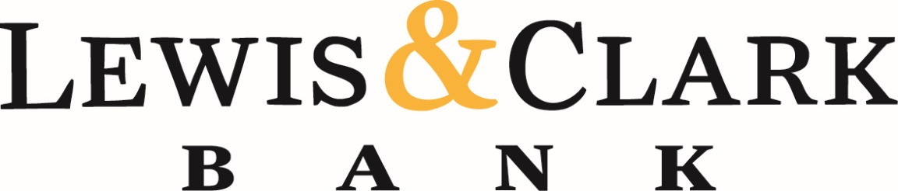

THANK YOU FOR SUPPORTING YOUR LOCAL BANK!

